Project Title

Abstract
Brief description about the problem and the finding results (500 word).

Introduction
Define the main problem of this project.
Brief description about the techniques used.
The main contribution you added to this project.
Organization of the reset of the project.

Related Work
Write some work related to this work with the accuracy achieved and methods applied at least 10 studies. It is better to add Table with the following Reference for the paper, Year, Methods, Results.

Methodology
Brief description of each method used.

Proposed Model
Describe each phase of your project with the methods implemented in each phase (Preprocessing, Feature selection, Feature Reduction, Classification/ Regression methods, Evaluation metrics)
Draw good model with high resolution such as the following.

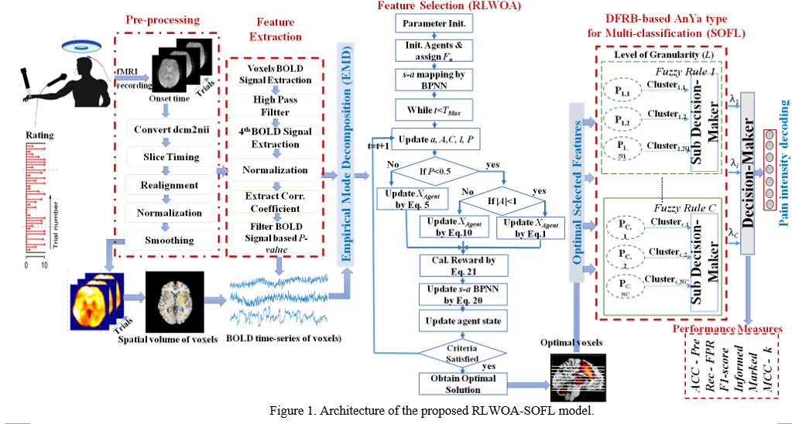
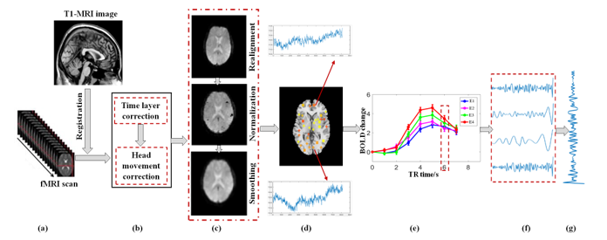

Results and discussion
- Write Data Sets Description
- Also write her the results of each method for each step and make tables and figures and compare different methods that we learnt in our course.
- Write the results of the preprocessing phase that you did with (Data Visualization, Missing Values Treatment, Binning process (If exist), Data Analysis (Min, Max, Mean, Variance, Standard Deviation, Skewness, Kurtosis). Data Analysis (Covariance matrix, Correlation, Heat map, Chi- square Test, Z-test or t-test, ANOVA))

- Write the Feature Reduction results and interpret and compare between them in good style.
Linear Discriminate Analysis (LDA)
Principle Component Analysis (PCA)
Singular Value Decomposition (SVD)

- Write the phase of classification / Regression methods results with Tables and Figures.

- Apply evaluation metrics and split Dataset to (80% training and 20% testing),

Apply K-fold cross validation and the average accuracy and compare between different algorithms using accuracy for each fold.

Apply the Confusion Matrix (Accuracy, Error rate, Precision, Recall, F-measure, and ROC) for each classifier and compare between in them in Table.

Interpret the results of confusion matrix and show the model overfitten or underfirren.

Conclusion and future work
Write her brief about your conclusion and your finding in the results and implementation.
Add your future work direction and how you can achieve better results using other methods or different dataset.

References
Cite the studies you read in this project and refer to it in the body of this project text by [Ref No.].
Write the reference of each paper in APA style as follows.
[1] Huang, W., Li, N., Lin, Z., Huang, G. B., Zong, W., Zhou, J., & Duan, Y. (2013, July). Liver tumor detection and segmentation using kernel-based extreme learning machine. In 2013 35th Annual International Conference of the IEEE Engineering in Medicine and Biology Society (EMBC) (pp. 3662-3665). IEEE.
[2] Sharma, A., & Kaur, P. (2013). Optimized liver tumor detection and segmentation using neural network. International Journal of Recent Technology and Engineering (IJRTE), 2(5), 7-10.
[3] Bilic, P., Christ, P., Li, H. B., Vorontsov, E., Ben-Cohen, A., Kaissis, G., ... & Menze, B. (2023). The liver tumor segmentation benchmark (lits). Medical Image Analysis, 84, 102680.
[4] Raj, A., & Jayasree, M. (2016). Automated liver tumor detection using Markov random field segmentation. Procedia Technology, 24, 1305-1310.

You can find the APA style from different places. One of this is google scholar like the following URL
https://scholar.google.com/scholar?hl=en&as_sdt=0%2C5&q=liver+tumor+detection+and+segmentation&oq=A+System+for+Liver+Tumor+Detection
